MZIMBA NORTH DISTRICT EXAMINATIONS Year: 2025
BIOLOGY FORM 1 MARKING KEY
SECTION A: Multiple choices (20 marks)
1. C
2. B
3. A
4. A
5. A
6. D
7. A
8. D
9. C
10. B
11. D
12. C
13. B
14. D
15. B
16. B
17. B
18. A
19. A
20. C
SECTION B: (50Marks)
Answer all the questions in the spaces provided
21. Figure below is a structure of a cell

a. Name the type of a cell?
Animal cell (1mark)
b. Give a reason for your answer in 2a above
It is enclosed by the cell membrane/does not have the cell wall (2 marks)
c. Identify the parts labelled A and B
A: nucleus (1 mark)
B: cytoplasm (1 mark)
22a. Give two reasons for classifying living things
To make it easier to study them
To make it easier to find information about them
It makes it easier to identify relationships between groups of organisms
To provide a coherent and universal system of grouping organisms (4 marks)
b. In the table below, draw the correct symbols against each of the following meaning (4marks)
Symbol | Meaning
 | The material can explode easily
 | Handle the material carefully, it can lead to irritation

c. Describe the three classes of animals according to what they eat
herbivores(1) –animals that feed on plant materials only(1)
carnivores (1)–animals that feed on the flesh of other animals(1)
omnivores(1)- animals that feed on mixed diet of animal flesh and vegetable matter (1) (6marks)
23. Figure below is a diagram showing leaves from different plants. Use it to answer the questions that follow;
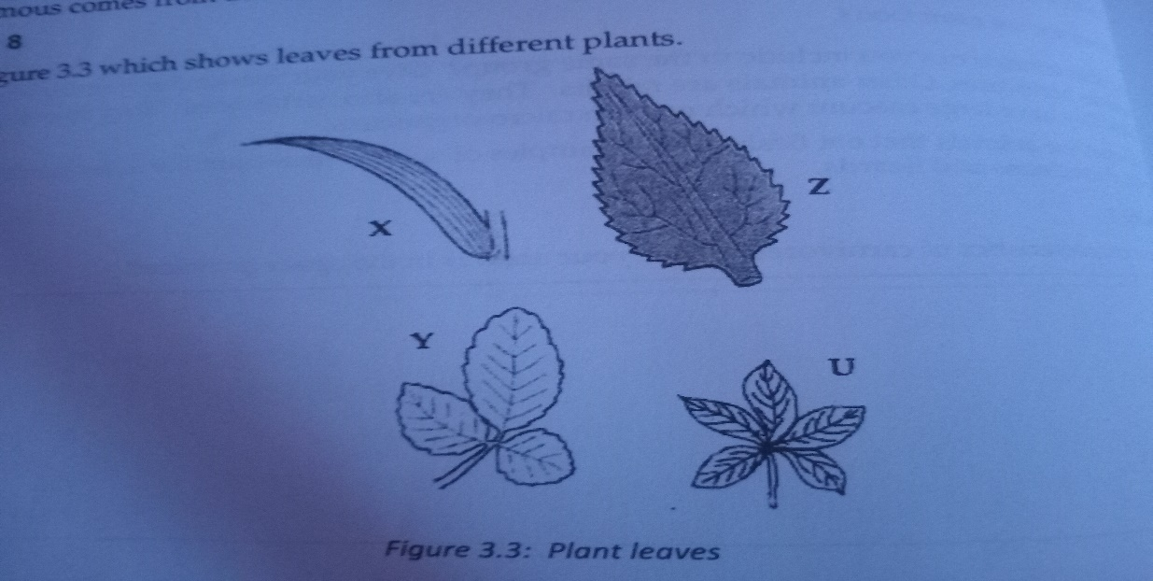
a. Use the following dichotomous key to identify the leaves
1a. A simple leaf ………………………………. See 2
b. A compound leaf ……………………………see 3
2a. Leaf with parallel veins ……………………..Zea mays
b. Leaf with serrated margins ………………….Hibiscus rosa-sinensis
3a. Leaf with trifoliate leaves …………………. Phaseolus vulgaris
b. Leaf with digitate leaves…………………….. Manihot esculenta
X: Zea mays (2marks)
Y: Phaseolus vulgaris (2 marks)
Z: Hibiscus rosa-senensi (2 marks)
U: Manihot esculenta ( 2marks)
b. What is a dichotomous key? (1 mark)
Is a set of instructions used to identify unknown organisms by using descriptions of observable features
Is a tool used to identify plants or animals by asking a series of questions, where each question is a choice between two characteristics.
Is an organized set of couplets(pair of statements) of mutually exclusive characteristics of biological organisms.
c. In the hierarchy below, fill in the missing categories

Kingdom
Phylum 1mark
Class
Order 1 mark
Family
Genus1mark
specimen

( 3 marks)

d. What does the term hierarchy mean
Is the ranking of organisms from the lowest taxonomic unit to largest taxonomic unit/ ranking of organisms from species to kingdom (1 mark)
24a. Give any two types of teeth
Inscisors
Canine
Molars
Premolars (2 marks)
b. Explain any two functions of the enamel part of the teeth
it protects the inner part of the tooth from infection(1) by bacteria and other micro-organisms(1)
it protects the inside of the tooth from mechanical damage(1) by hard food materials(1)
it provides a hard biting surface(1) for effective chewing of food (1)(4 marks)
25a. Give any two risk factors in science laboratory
Burns
Poisoning (2 marks)
b. Name the apparatus in biology laboratory whose uses are the following;
i. for holding test tubes: test tube racks / test tube holders (1 mark)
ii. for measuring and pouring solutions drop by drop: dropper (1 mark)
iii. for holding hot substances: tongs ( 1 mark)
iv. for heating and holding liquids: beaker, conical flask (1 mark)
c. Explain the functions of each of the following parts of a microscope
i. Eyepiece:
magnifies the object under observation (1 mark)
ii. Diaphragm
controls the amount of light passing from the light source to the condenser (1mark)
27. Figure below is a diagram of a foot of a bird showing feeding adaptation. Use it to answer the questions that follow

a. To which group of animals does the bird with such a foot belong?
Passriformes (1 mark)
b. Name an example of a bird whose foot is in the figure above
sparrow (1 mark)
c. Explain the use of the bird’s foot in the figure above
for perching and grasping twigs (2 marks)
SECTION C (30 marks)
28. Explain any five characteristics of living things
.Nutrition (1)– process by which organisms obtain food from the environment(1)
.Respiration (1) – food substances are broken down in the body to release energy (1 )/ is the process in which energy is released from food in the body of an organism
.Excretion (1) – remove of waste products of metabolism from the body (1)/ the removal of metabolic wastes from an organism
.Reproduction(1) – production of young ones (1)/ is the process where new organisms arise from the already existing ones either by sexual or asexual means.
Growth and development (1) –permanent increase in size and mass of organisms (1)
.Sensitivity (irritability)(1)- the ability of organisms to sense changes in their environment and respond to them(1)./ is the ability to respond to changes in the environment
(10 marks)
29.Explain any five rules of using glassware safely in the laboratory
It should be well fastened to racks, ring stands or retort/clamp(1) to prevent them from falling and breaking(1)
Support round bottom flask with cork rings and stopper openings (1) to prevent them from rolling over
Provide enough space between glassware during storage(1) to prevent them from vibrating and breaking each other(1)
When heating substances, use glassware that are specifically made for heating (1) because if you use any other glassware, the heat may break them(1)
During movement,(1) place cushioning material between them(1) to prevent them from breaking(1) (10 marks)
30. Describe five functions of parts of a plant cell
Cell wall – provides fixed shape of a cell/ freely allows gases and water to enter the cell
Cell membrane – encloses cell contents /regulates movements in and out of a cell
Cytoplasm – medium for all reaction / stores glycogen and starch
Vacuole – stores food substances in the cell / Its where life (chemical reactions) inside the cell takes place. /it controls osmotic potential of the cell.
Nucleus – stores genetic material / controls activities of the cell
Chloroplast- bounds the nucleus/ it selects what must enter the or leave the fluid inside the cell./site for photosynthesis since it contains chlorophyll. (10 marks)

